**ANALYSIS OF JOBS IN DATA SCIENCE IN RECENT TIMES**

**INTRODUCTION**

In recent years, the field of data science has experienced a rapid and profound evolution, transforming the way businesses operate and make decisions. The proliferation of digital technologies, coupled with the exponential growth of data, has fueled the demand for skilled professionals in data science roles across various industries.

The introduction of data science jobs has reshaped traditional business models, leading to a paradigm shift where data-driven insights are central to organizational strategies. These roles encompass a wide range of responsibilities, from collecting, cleaning, and processing data to deriving actionable insights and predictions through advanced analytics and machine learning techniques.

**ACKNOWLEDGEMENT:**

We Omprava Mandal, Supritha Pal, Payel Ghosh, and Pallabi Dutta would like to express our sincere gratitude and appreciation to each other who contributed to the successful execution of this data science job analysis project. We extend our thanks to each member for their collaboration, contributions, and dedication, which significantly enriched the project's outcomes.

The csv file is being found, downloaded, and then cleaned and the project is being executed by our team members with help of our mentor.

We are deeply thankful to Suramya Biswas sir for the guidance, support, and invaluable insights provided throughout the duration of this project.

We are grateful to Anudip Foundation for granting access to essential resources, datasets, and tools crucial to conducting thorough analyses.

We acknowledge the creators and contributors of Python, Word that were instrumental in data collection, analysis, and visualization.

This project would not have been possible without the collective efforts and support of each individual and entity mentioned above. Our team contributions have been invaluable in shaping the outcomes and enhancing the quality of this endeavor.

**OBJECTIVES:** Here are some potential objectives:

**Trend Analysis**: Understand the overall trend in demand for data science jobs over a specific period. In our project, the demand for data science is increasing in an exponential height, especially in foreign countries.

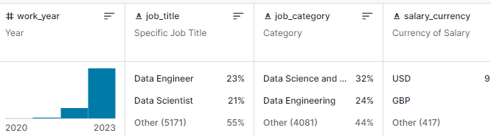

**Geographical Distribution**: The geographical distribution of data science jobs has been widespread in recent times, with major hubs including Silicon Valley, New York, London, and Bangalore. However, the demand for data scientists has been expanding globally, with emerging hubs in cities like Berlin, Singapore, and Tel Aviv. Remote work options have also increased, allowing professionals to contribute to the field from various locations.

Countries vs job graph

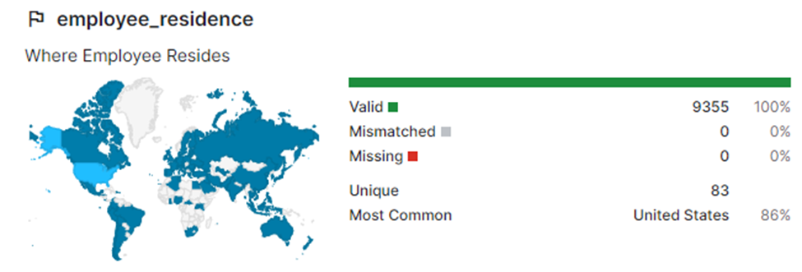

Data science jobs have seen significant demand across various industries. Technology companies, finance, healthcare, e-commerce, and consulting firms continue to heavily invest in data science talent. Additionally, industries such as manufacturing, energy, and logistics are increasingly leveraging data science for process optimization and decision-making. The interdisciplinary nature of data science allows it to permeate through diverse sectors, making it a crucial skillset in today's job market.

**Salary Trends**: As of my last knowledge update in January 2022, data science salaries continued to be robust, with variations based on factors such as experience, location, and industry. Generally, data scientists with advanced degrees and several years of experience tended to command higher salaries. Tech hubs like Silicon Valley, New York, and Seattle often offered higher compensation due to the demand for skilled professionals.

Salaries vs work titles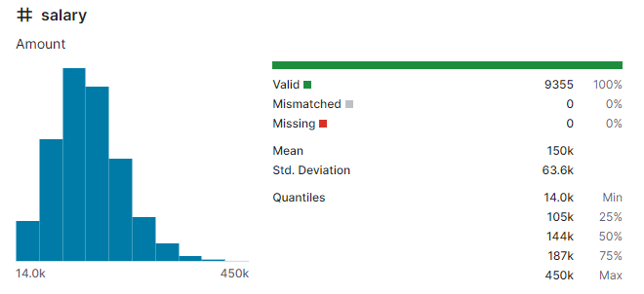

However, salary trends can change over time based on market dynamics, so it's advisable to consult the latest industry reports, job market analyses, and salary surveys for the most up-to-date information on data science salaries in 2024.

**Comparison Across Companies**: Different companies may emphasize distinct aspects of data science jobs based on their specific needs and industries. Tech giants like Google, Amazon, and Microsoft often focus on large-scale data processing, machine learning, and artificial intelligence. Financial institutions like JPMorgan Chase or Goldman Sachs may emphasize data analytics for risk management and financial modeling.

Startups often require data scientists to wear multiple hats, engaging in both analysis and implementation. Healthcare companies like IBM Watson Health may prioritize data scientists working on healthcare analytics and predictive modeling.

It's essential to consider the industry, company size, and specific business goals when comparing data science job requirements across companies. Each organization tailors data science roles to address its unique challenges and objectives.

**LIBRARIES AND TOOLS:**

* NumPy: For numerical computations and statistical analysis.
* Matplotlib: For creating visualizations and plots.
* Pandas: For data manipulation and analysis.
* Basic Python: For handling data structures like arrays, tuples, and basic operations.

**DATA COLLECTION STEPS:**

Data sources is being identified from Kaggle. The CSV file is downloaded and the information and dataset is being collected.

**Define Data Structure**:

Determining the information for collecting for each job posting: job title, company, location, description, required skills, experience level, salary, etc.

**Data Collection Execution**:

The extracted data is stored in a structured format i.e, csv file. It is being formatted, cleaned, and executed.

**EXPLORATORY DATA ANALYSIS (EDA)-**

is crucial for understanding the characteristics and patterns within the collected dataset.

Here's a structured approach using Python libraries like Pandas and Matplotlib:

Exploratory Data Analysis Steps:

**Data Loading:**

We are using Pandas to load the dataset (CSV) collected during the data collection phase.

**The dataset is loaded and read**



**Dataset description**

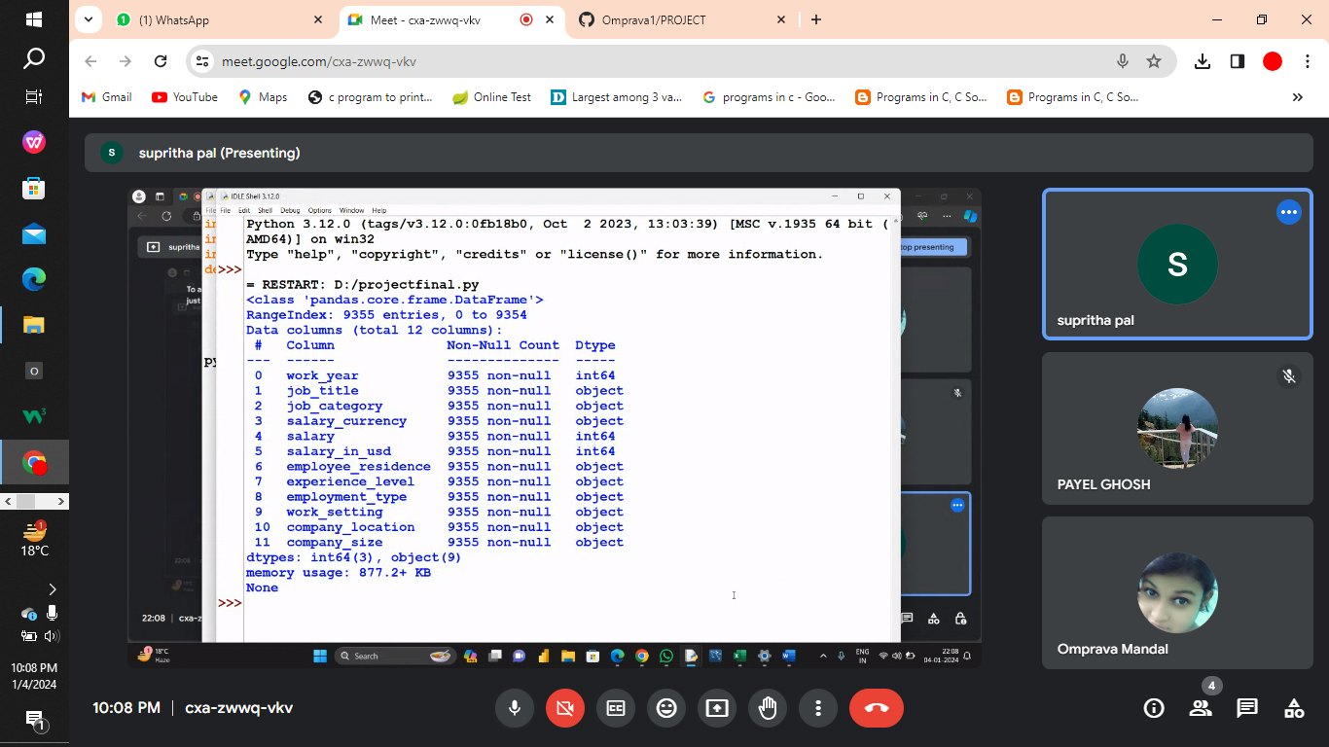

**Check for missing values**





**Drop columns with any missing values**



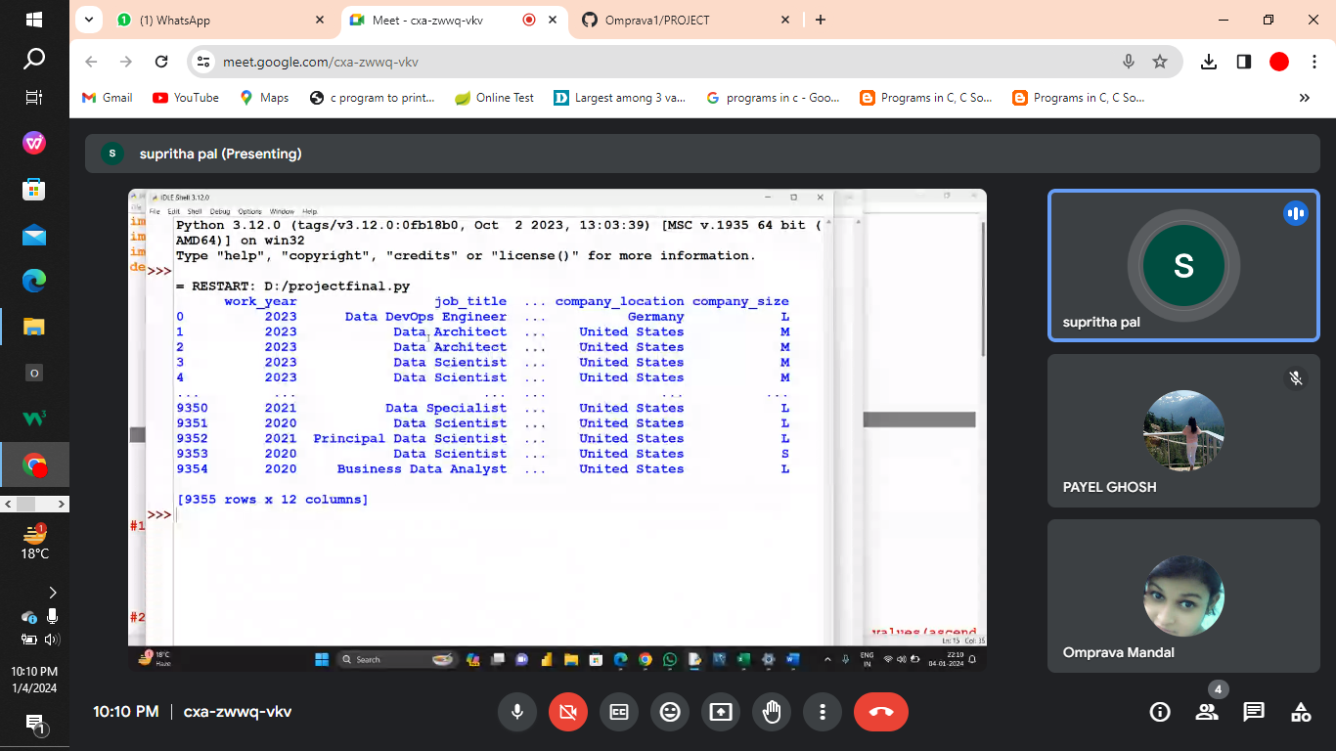

**Drop rows with missing values**

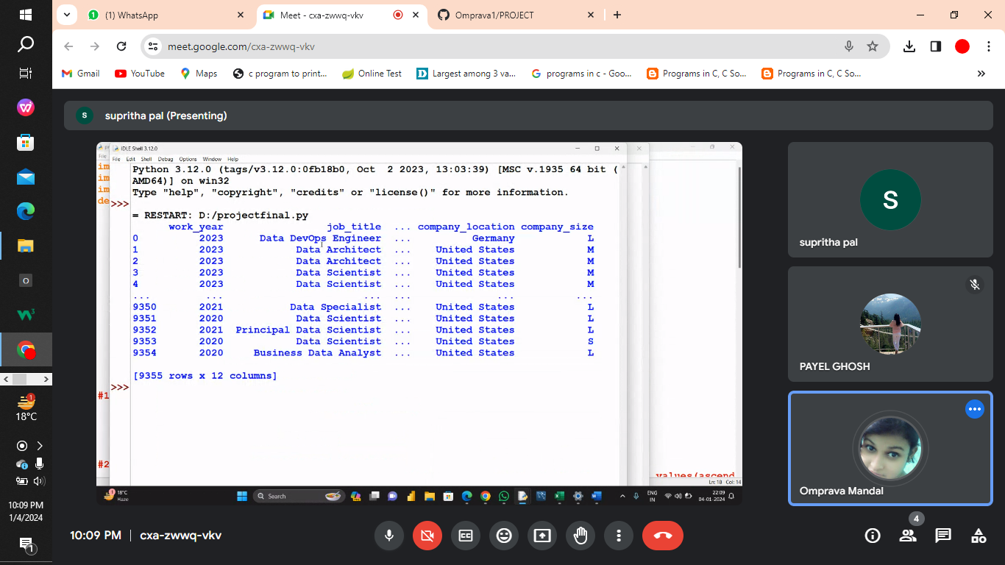

**Data (after cleaning)**

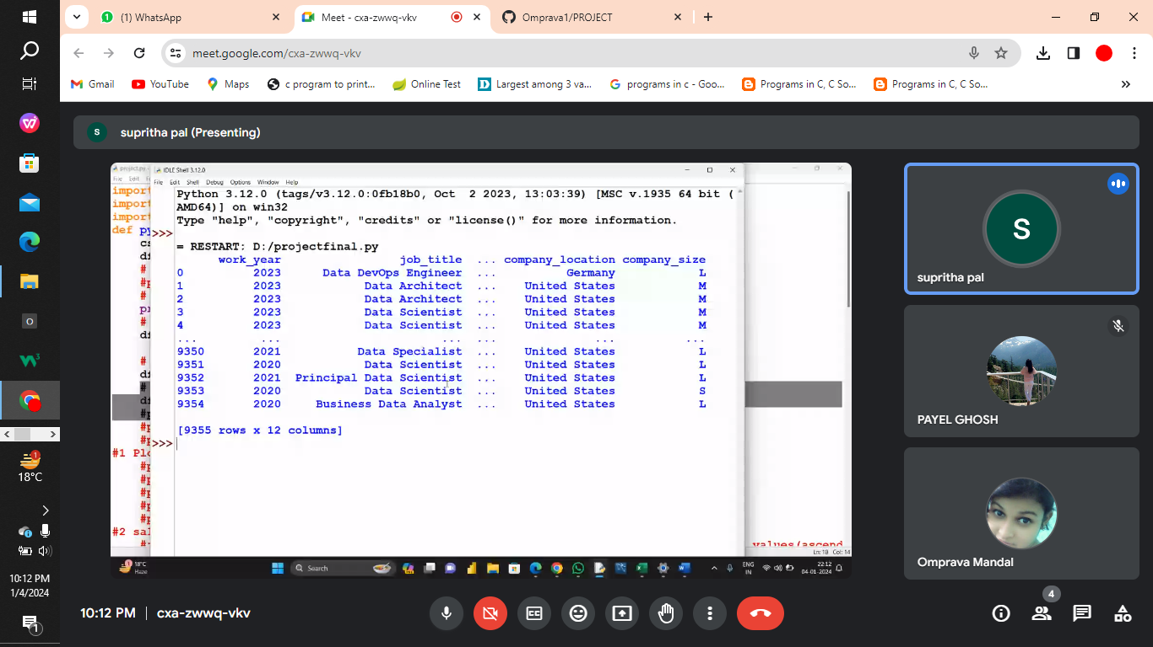

**Dataset Description with the titles**



**CONTEXT QUESTIONS**

**Project Scope and Objectives**

* How does this project show the leniency towards data science field?

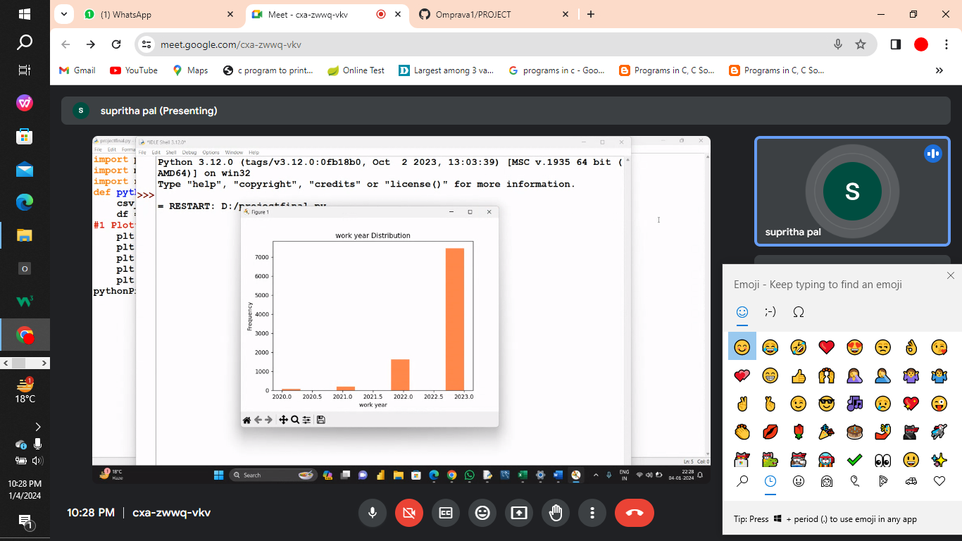

* Which countries are currently showing a high demand for data science professionals?

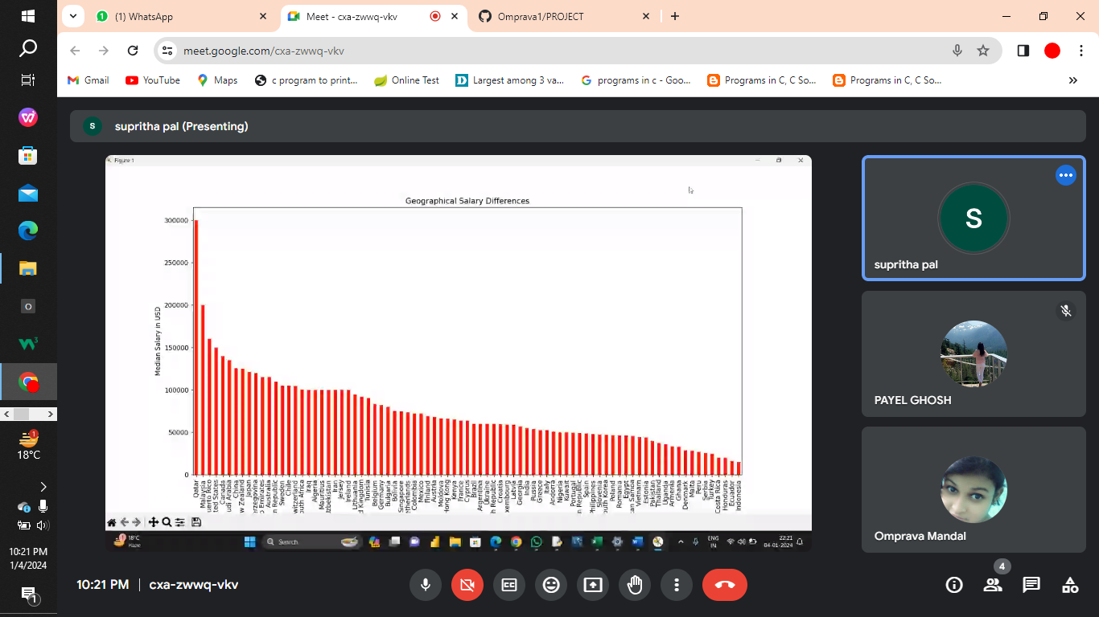

* In what ways has the industry focus for salaries for data science jobs evolved over the past few years?

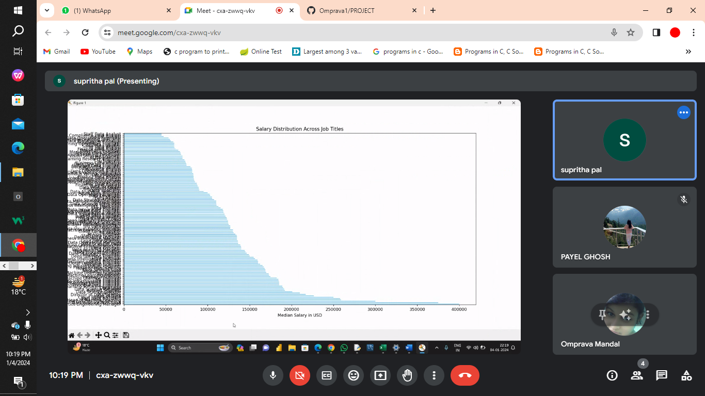

**Data Collection and Sources:**

* What sources or datasets are being utilized for this job analysis?





* How was the data collected, and what steps were taken to ensure its accuracy and relevance?

Data has been collected from Kaggle, ChatGPT, and YouTube and after that it is being utilized in the analysis of the data science job.



**Dataset Questions**

1. Which countries recruits and pays maximum salaries?



1. Which year the jobs for data science field is maximum?



;

1. What is the part of data science jobs in all fields of work?
2. What is the salary distribution based on experience level of employees?



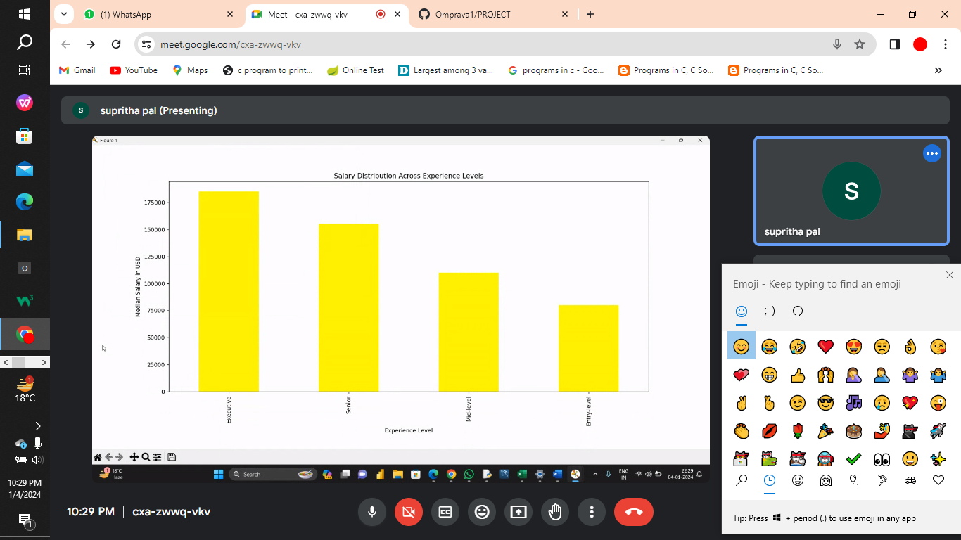

1. What is the effect of employee type on salary structure?



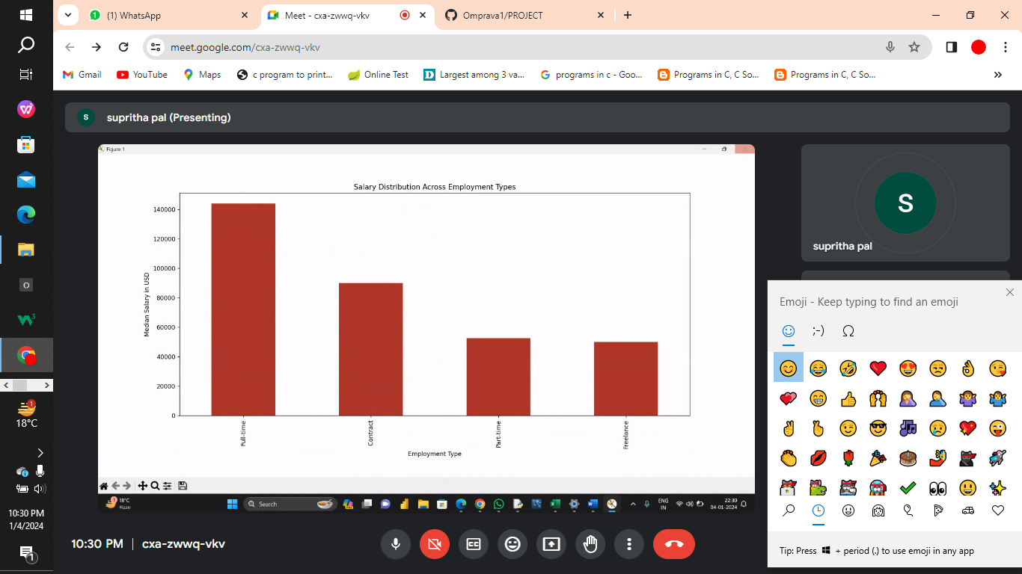

**Analysis result**

* What is the amount of people getting employed in data science jobs in recent years?



* What is impact of work setting on salary levels?

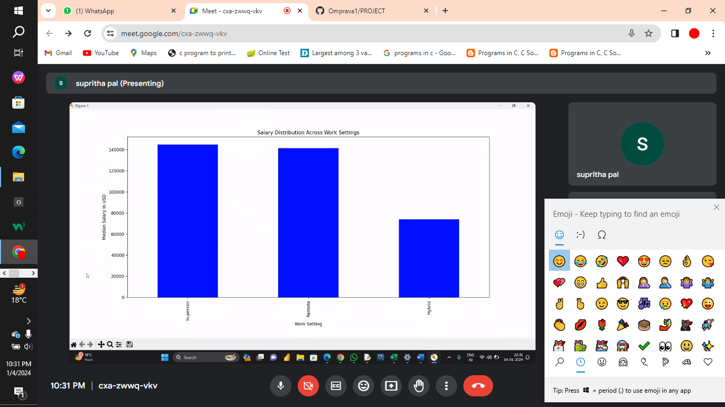

* How many employees got the job in different countries other than India?



* What is the relationship between company size and the salary distribution?

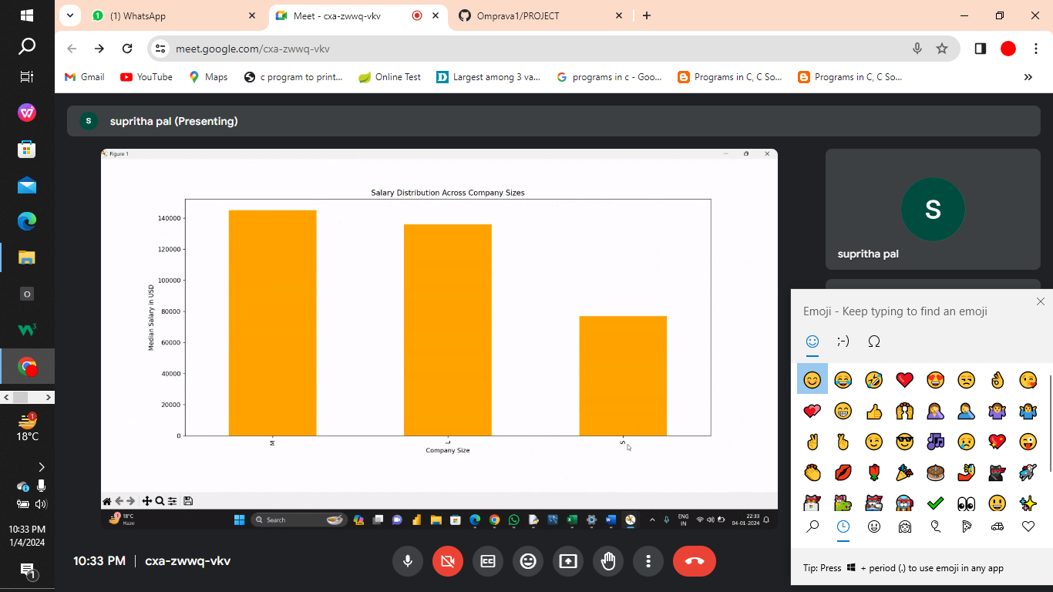

**DATA VISUALIZATION:**

**Work year showing different job category**



**Geographical Analysis:**

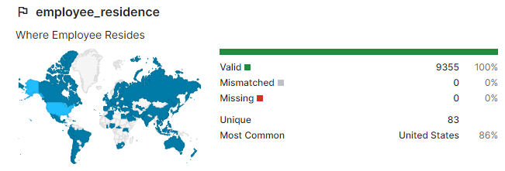

job distribution in a graph is visualized.

**Salary Trends**

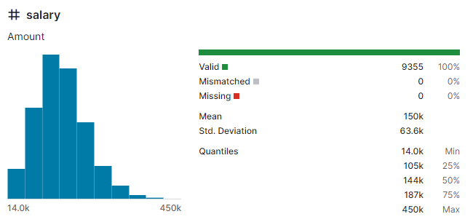

Work Setting

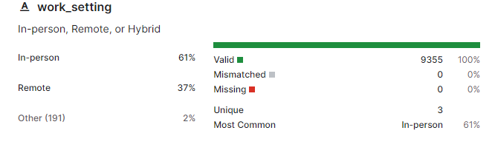

Employment type:

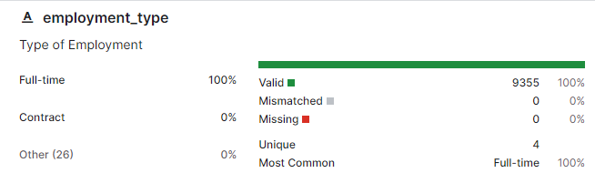

WORK IN DATASCIENCE JOBS AND OTHER FIELDS

**CONCLUSION:**

The demand for data science talent continues to outpace supply, leading to a competitive job market where organizations seek individuals with a blend of technical proficiency and domain-specific knowledge. As businesses increasingly rely on data to drive decision-making, data science roles have become integral across sectors like finance, healthcare, retail, and technology.

In conclusion, the rise of data science jobs represents a fundamental shift in how businesses harness information to gain a competitive edge. The evolution of these roles reflects a growing recognition of the value of data-driven insights and the pivotal role played by skilled professionals in extracting meaningful information from vast datasets to drive innovation and strategic decision-making.

**FUTURISTIC APPROACH:**

The field of data analytics is experiencing a rapid expansion, with a strong demand for skilled professionals who can derive meaningful insights from vast amounts of data.



As we progress into 2023, a number of emerging trends are reshaping the landscape of data analytics careers. Hence, data science opens a huge field or arena of jobs and careers in both remote and foreign areas.